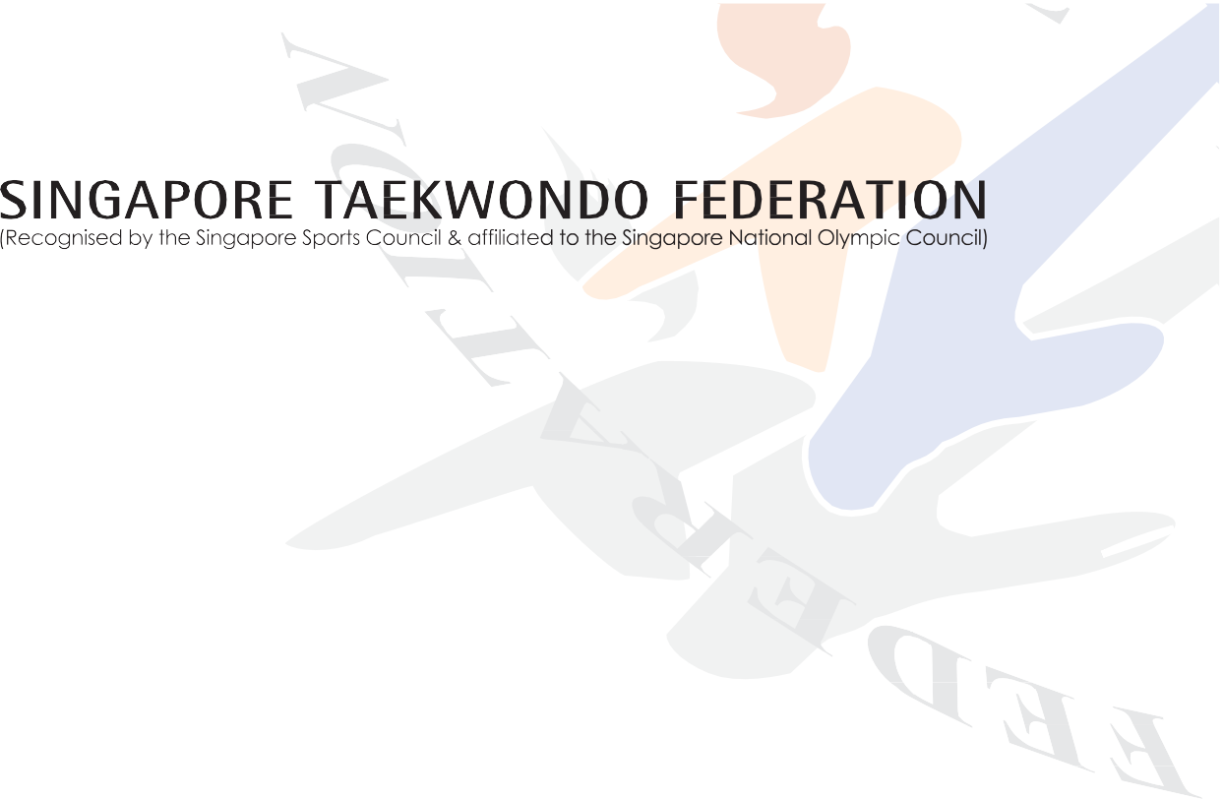
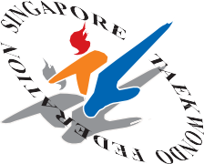

SINGAPORE TAEKWONDO FEDERATION

45TH ANNUAL GENERAL MEETING 2022
24 September 2022 (Saturday), 2pm

DELEGATE REGISTRATION FORM

Name of Affiliate:

According to STF Constitution clause 15.2, a member or his authorised delegate shall be entitled to attend and vote at General Meetings.
Affiliates can nominate an authorised delegate if he/she is not able to attend the AGM by filling up the table below:

S/N | Name | Designation | Email | NRIC (Last 3 digits + last letter)
1

_____________________ ___________
Signature/Stamp Date
Name:
Designation (in Affiliate):

*Please return the completed form (with the subject title – “STF AGM 2022: Affiliate’s Name”) via email to stkdf.agm@gmail.com by 6.00pm on Friday, 9 September 2022

