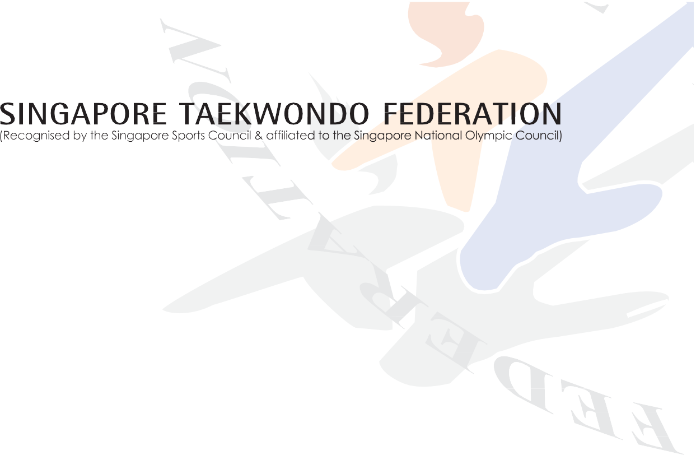
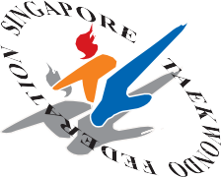

SINGAPORE TAEKWONDO FEDERATION

EXTRAORDINARY GENERAL MEETING 2023
7 January 2023 (Saturday), 2pm

DELEGATE REGISTRATION FORM

Name of Affiliate:

According to STF Constitution clause 15.2, a member or his authorised delegate shall be entitled to attend and vote at General Meetings.
Affiliates can nominate an authorised delegate if he/she is not able to attend the EOGM by filling up the table below:

S/N | Name | Designation | Email | NRIC (Last 3 digits + last letter)
1

_____________________ ___________
Signature/Stamp Date
Name:
Designation (in Affiliate):

*Please return the completed form (with the subject title – “STF EOGM 2023: Affiliate’s Name”) via email to stkdf.agm@gmail.com by 6.00pm on Tuesday, 27 December 2022

